Internship Report

**NULLCLASS**

Internship Report on Twitter Data Analysis and Visualization using Power BI

Submitted by: Abhay Singh  
Internship Duration: 07-01-2025 to 07-02-2025 (1 Month)

Submitted to: NULLCLASS  
Submission Date: 04-02-2025

|  |  |  |
| --- | --- | --- |
| **s.no** | **Table of Contents** | **Page no.** |
| 1 | Introduction | 3 |
| 2 | Background | 3 |
| 3 | Learning Objectives | 4 |
| 4 | Activities and Tasks   * Visualizing Average Engagement Rate and Total Impressions * Scatter Chart for Media Engagement Analysis * Comparative Visualization for Replies, Retweets, and Likes | 4 - 5 |
| 5 | Skills and Competencies | 6 |
| 6 | Feedback and Evidence | 7-8 |
| 7 | Challenges and Solutions | 9 |
| 8 | Outcomes and Impact | 9 |
| 9 | Conclusion | 10 |

**1. Introduction**

This report summarizes my internship experience at NULLCLASS, including the tasks I performed, the skills I developed, and the challenges I overcame. My focus during the internship was on Twitter data analysis and visualization using Power BI, incorporating advanced filtering and time-based visibility constraints to enhance data insights and decision-making.

**2. Background**

During this internship at NULLCLASS, I was involved in analysing Twitter engagement data and developing interactive dashboards. The objective is to create meaningful insights that help in understanding user engagement patterns and optimizing social media strategies. Tasks included working with Power BI to filter, visualize, and analyse tweets based on various parameters. My role was implementing dynamic constraints and ensuring data accuracy while maintaining dashboard responsiveness.

**3. Learning Objectives**

- Get hands-on experience in using Power BI and data visualization methods.

- Use advanced filtering conditions to analyse the data and take better analytical decisions.

- Be able to handle time-based constraints in dashboards to enhance the real-time analysis.

- Ability to solve the problems by breaking through the difficulties in data, thereby enhancing efficiency in data processing.

**4. Activities and Tasks**

Some of the activities performed during this internship are:

1. **Average Engagement Rate and Total Impressions in Visualization:**

Created a visual that depicts the average engagement rate and total impressions for the tweets posted between January 1, 2020, to June 30, 2020.

Used filters to exclude the ones that have less than 100 impressions and those having 0 likes.

Faced the issue of the graph being visible only between 3 PM IST and 5 PM IST so that it falls in the peak engagement window.

2. **Scatter Chart for Media Engagement Analysis:**

Developed a scatter chart to analyze the relationship between media engagements and media views for tweets with more than 10 replies.

Highlighted tweets with an engagement rate above 5% to identify high-performing content.

Applied restrictions so that the chart is visible only between 6 PM IST and 11 PM IST.

The data was further refined to only include tweets on odd-numbered dates with more than 50 words to be deep in content.

3. **Comparative Visualization for Replies, Retweets, and Likes:**

Comparing replies, retweets, and likes was visualized on a comparison visualization for those who have engaged their tweets more than the median value.

Added filters of tweets posted during June to August 2020 to look specifically at seasonal patterns of engagement

Included visibility constraints to capture 3 PM IST and 5 PM IST as well as 7 AM IST to 11 AM IST to really pinpoint peak times of engagement.

Churned in further to show only those that had odd number dates, even number media view counts, and character count was above 20.

Eliminated tweets containing the word 'S' to see what happens with regards to linguistic impacts on engagement.

**5. Skills and Competencies**

Advanced Power BI Data Visualization techniques

Implementation of complex filtering conditions to enhance precision in analysis.

Time-based constraints for visibility of data in the dashboard for efficient interpretation of the data.

Data preprocessing and transformation for more precise and reliable findings.

Problem solving and analytical skills to maximize results from data-driven decision-making

**6. Feedback and Evidence**

The internship at NULLCLASS provided valuable insights into real-world data analysis. Feedback from mentors highlighted my ability to implement complex filters effectively, ensuring that the dashboards met all required business specifications. The dashboards created demonstrated proficiency in Power BI, data visualization, and structured data representation for actionable insights.

Screenshots:  
  
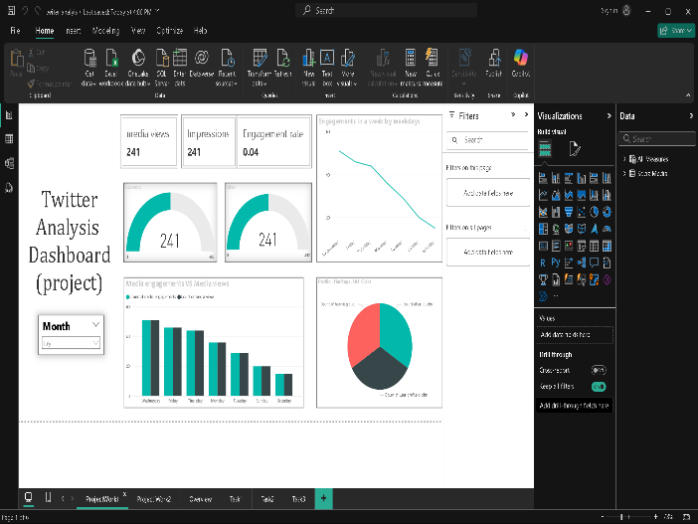 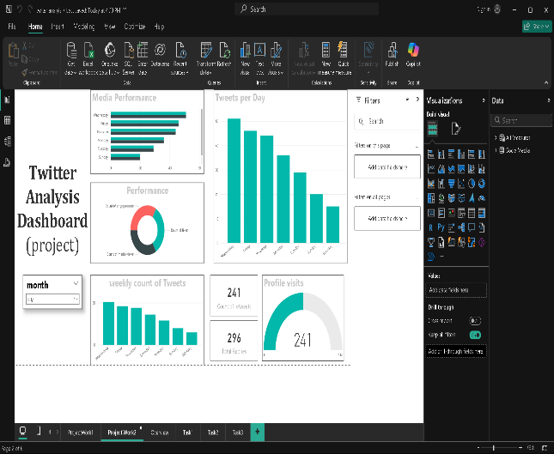

Twitter analysis dashboard (Project)

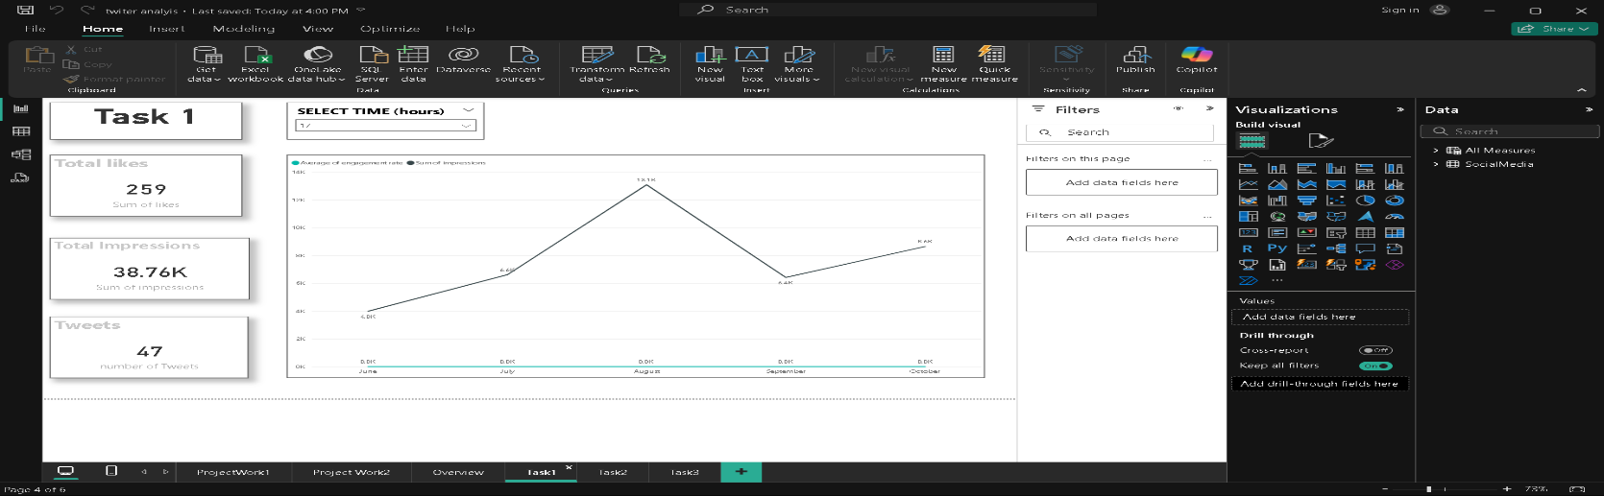

Task 1

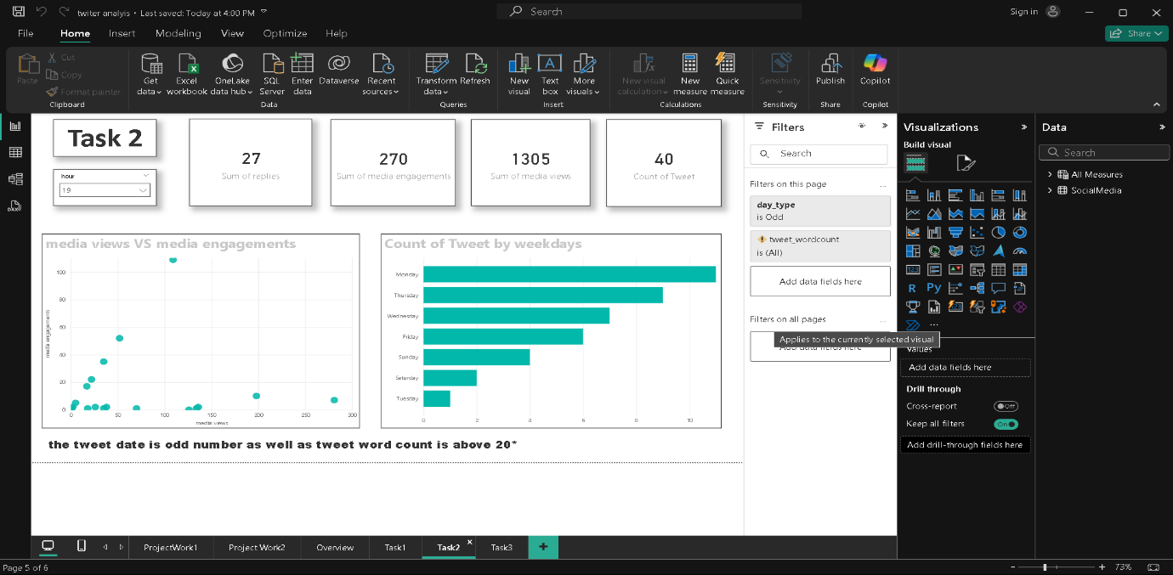

Task 2

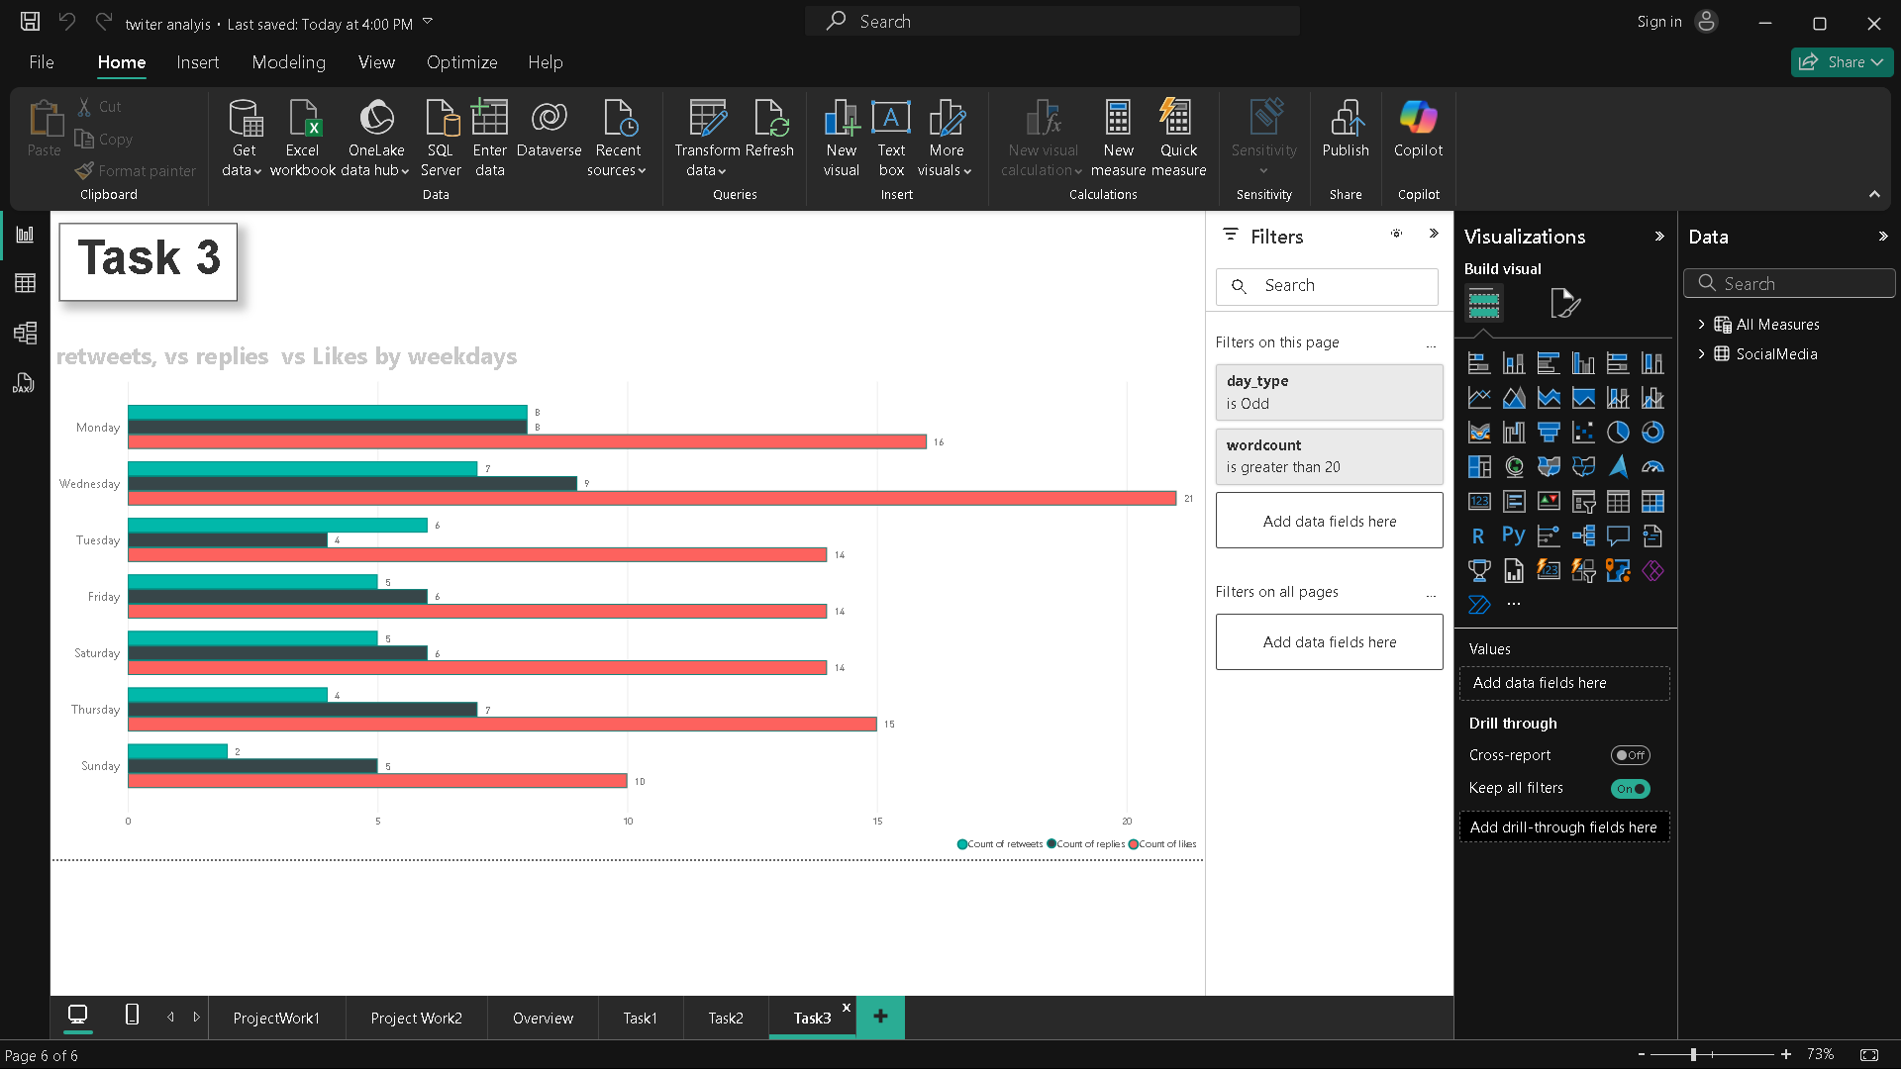

Task 3

**7. Challenges and Solutions**

- Complex Filtering Conditions: It involved refining the query logic and using DAX expressions effectively to optimize processing speed and accuracy.

- Time-based Visibility Constraints: The visibility logic was implemented using dynamic filters to ensure graphs appeared at the right times, maintaining user engagement relevance.

- Data Cleaning and Transformation: Power Query was used to preprocess tweets to ensure data met the specified conditions while enhancing overall dataset quality.

**8. Results and Consequences**

- Created dynamic, interactive dashboards to address business requirements and improve decision-making.

- Developed expertise in Power BI and sophisticated data analysis.

- Deeper understanding of engagement metrics in relation to optimization of digital strategies.

- Offered insightful perspectives into Twitter user engagement patterns and supported content strategy refinement at NULLCLASS.

**9. Conclusion**

This internship at NULLCLASS was a highly enriching experience that enhanced my technical and analytical skills. The tasks provided a hands-on opportunity to work with real-world data, and the challenges helped me develop strong problem-solving abilities. The knowledge gained will be beneficial for future projects and career growth in data analytics, visualization, and digital strategy optimization.